Wildlife Animal Detection and Alert System Using Computer Vision

A project report submitted to ICT Academy of Kerala
in partial fulfillment of the requirements
for the certification of

CERTIFIED SPECIALIST
IN
MACHINE LEARNING AND ARTIFICIAL INTELLIGENCE

submitted by
Team - 2
Supunya Santhosh
Jayalekshmi D S
Sanju Tom
Vidya L


ICT ACADEMY OF KERALA
THIRUVANANTHAPURAM, KERALA, INDIA
Jan 2026
List of Figures

Fig. 1: System Architecture of the Wildlife Animal Detection and Alert System……..10

List of Abbreviations

- AI Artificial Intelligence
- ML Machine Learning
- DL Deep Learning
- CV Computer Vision
- YOLO You Only Look Once
- CNN Convolutional Neural Network
- OpenCV Open Source Computer Vision Library
- API Application Programming Interface
- REST Representational State Transfer
- HTTP Hypertext Transfer Protocol
- HTTPS Hypertext Transfer Protocol Secure
- UI User Interface
- DB Database
- SQL Structured Query Language
- SQLite SQLite Database
- SMS Message Service
- CCTV Closed-Circuit Television
- IoU Intersection over Union
- mAP Mean Average Precision
- FPS Frames Per Second
- TP True Positive
- FP False Positive
- FN False Negative
- F1 F1 Score
- SMTP Simple Mail Transfer Protocol
- Flask Python Web Framework
- Roboflow Computer Vision Dataset and Model Platform

Table of Contents
Abstract………………………………………………………………………...5
1.Problem Definition…………………………………………………………..6
  - Overview……………………………………………………………..6
  - Problem statement……………………………………………………6
2.Introduction………………………………………………………………….7
2.1 Wildlife Monitoring and Detection……………………………….…..8
2.2 Computer Vision and YOLO………………………………………….8
2.3 Technologies Used…………………………………………………….9
3.Literature Survey……………………………………………………………11
4.System Design ……………………………………………………………….13
4.1 System Architecture…………………………………………………13
7. Result
8. Conclusion

Abstract

Human–wildlife interactions can pose significant risks to people, livestock, property, and wildlife, particularly in areas located near forests and wildlife habitats. Manual monitoring of such areas is time-consuming and may not provide timely warnings when animals enter populated or restricted regions.
This project proposes a Wildlife Animal Detection and Alert System using Computer Vision and YOLO (You Only Look Once) for automated detection of wildlife in images and video streams. The system will initially focus on detecting tigers and elephants using a custom dataset containing annotated images with bounding boxes. A pretrained YOLO model will be fine-tuned on the custom wildlife dataset to identify the target animals and determine their location within each frame.
The system will use OpenCV for image and video processing and will be tested using images, prerecorded videos, and a webcam. When a target animal is detected with a confidence score above a predefined threshold, the system will generate an alert and can send an SMS notification and email to a registered user. A cooldown mechanism can be implemented to prevent repeated alerts for the same detection.
The performance of the system will be evaluated using metrics such as precision, recall, F1-score, mAP (mean Average Precision), detection confidence, and response time. The proposed system can be further extended to support additional wildlife species and integration with CCTV or IP cameras for continuous real-time wildlife monitoring.

1. Problem Definition
1.1 Overview
Human–wildlife conflict is a growing concern in areas located near forests and wildlife habitats. Early detection of wild animals such as tigers and elephants can help reduce risks to humans, livestock, property, and wildlife. With the advancement of computer vision and deep learning, automated object detection systems can be used to monitor images and video streams and identify animals in real time.
This project focuses on developing a Wildlife Animal Detection and Alert System using YOLO and OpenCV. The system is designed to detect target wildlife, locate them using bounding boxes, and generate alerts when a detected animal meets a predefined confidence threshold. The proposed system aims to reduce the need for continuous manual monitoring and provide timely notifications to users.
1.2 Problem Statement
The presence of wild animals such as tigers and elephants near human settlements, farms, roads, and other populated areas can create serious safety risks for humans, livestock, property, and the animals themselves. Traditional wildlife monitoring methods often depend on manual observation or continuous surveillance, which can be difficult, time-consuming, and ineffective for providing immediate warnings.
There is a need for an automated system capable of continuously analyzing images and video streams and identifying potentially dangerous wildlife without requiring constant human monitoring.
The proposed project addresses this problem by developing a YOLO-based wildlife object detection and alert system. The system will process images and video using OpenCV and use a trained YOLO model to detect and localize target animals such as tigers and elephants using bounding boxes and confidence scores.
When a target animal is detected with sufficient confidence, the system will automatically trigger an alert and send an SMS and email notification to a registered user. The system will initially be evaluated using images, prerecorded videos, and webcam input, with the possibility of extending it to CCTV/IP camera feeds.
The effectiveness of the system will be measured using precision, recall, F1-score, mAP, detection speed, and alert response time. The overall goal is to develop an automated, scalable, and practical wildlife monitoring solution that can provide early warnings and support safer coexistence between humans and wildlife.

2. Introduction
Wildlife plays an important role in maintaining ecological balance and biodiversity. However, increasing human activities near forests, wildlife habitats, agricultural areas, and residential communities have increased the possibility of human–wildlife interactions. The presence of animals such as elephants, tigers, leopards, and wild boars near human settlements can result in risks to human safety, agricultural resources, and wildlife itself. Therefore, early detection and timely notification of wildlife presence are important for reducing potential conflicts and enabling appropriate preventive action.
Traditional wildlife monitoring methods often depend on human observation, manual inspection of camera footage, or physical monitoring systems. These approaches can be time-consuming and may not provide immediate detection, particularly when monitoring large areas continuously. The increasing availability of cameras and advances in Artificial Intelligence (AI) and Computer Vision (CV) provide an opportunity to automate this process.
This project proposes a Wildlife Animal Detection and Alert System Using Computer Vision that uses the You Only Look Once (YOLO) object detection algorithm to automatically identify and locate animals in images, videos, and camera feeds. The system is designed to detect multiple wildlife classes, including elephants, leopards, tigers, and wild boars, using bounding boxes and confidence scores.
The system integrates YOLO with OpenCV for image and video processing. When a target animal is detected with a confidence value above a predefined threshold, the system records the detection and can generate an alert through email or SMS. An administrator can configure alert information such as the email address, phone number, confidence threshold, and alert settings through a web-based dashboard developed using Flask.
The proposed system aims to reduce dependence on continuous manual monitoring and provide a more automated approach to wildlife surveillance. The performance of the detection model is evaluated using standard object-detection metrics such as precision, recall, F1-score, mAP@50, and mAP@50-95, along with detection speed and alert response time.
The project can be further extended to support real-time CCTV, IP cameras, and thermal cameras, as well as additional wildlife species and more advanced automated decision-making capabilities. The overall system demonstrates how AI and Computer Vision can be combined with web technologies and communication services to develop an automated wildlife monitoring and alert solution.

2.1 Wildlife Monitoring and Detection

Wildlife plays an important role in maintaining ecological balance and biodiversity. However, increasing human activities near forests, wildlife habitats, agricultural areas, and residential communities have increased the possibility of human–wildlife interactions. The presence of animals such as elephants, tigers, leopards, and wild boars near human settlements can result in risks to human safety, agricultural resources, and wildlife itself. Therefore, early detection and timely notification of wildlife presence are important for reducing potential conflicts and enabling appropriate preventive action.
Traditional wildlife monitoring methods often depend on human observation, manual inspection of camera footage, or physical monitoring systems. These approaches can be time-consuming and may not provide immediate detection, particularly when monitoring large areas continuously. The use of automated monitoring systems can help reduce the dependence on continuous manual observation and support faster identification of wildlife.

2.2 Computer Vision and YOLO

Computer Vision enables computers to process and interpret visual information from images and videos. In this project, Computer Vision is used to automatically identify wildlife animals from visual input.
The project uses the You Only Look Once (YOLO) object detection algorithm to detect and locate animals in images and videos. Unlike simple image classification, object detection identifies both the class of the animal and its location using a bounding box. The trained model detects four wildlife classes: Elephant, Leopard, Tiger, and Wild-Boar.
The YOLO model produces a class label, bounding box, and confidence score for each detected animal. A predefined confidence threshold is used to determine whether a detection should be considered for generating an alert. OpenCV is used for processing images and video frames and for displaying the detection results.

2.3 Technologies Used

The proposed Wildlife Animal Detection and Alert System uses Python-based computer vision and machine learning technologies. The main technologies and their purposes are listed in Table 1.

Table 1: Technologies Used

Technology | Purpose
Python | Main programming language used for AI model integration, video processing, and backend development.
YOLO 11 | Used for detecting and classifying wildlife such as Elephant, Leopard, Tiger, and Wild Boar using bounding boxes and confidence scores.
OpenCV | Used for reading, processing, resizing, and displaying video frames and camera feeds.
Flask | Used to develop the backend web application, manage users, alerts, database operations, and system functionality.
Streamlit | Used to create a user-friendly frontend for uploading wildlife videos and displaying detection results.
REST API | Provides communication between the AI detection module and the backend for transmitting detection and alert information.
SQLite / Database | Stores user information, wildlife detection records, confidence scores, timestamps, tracking IDs, and notification status.
Email Notification | Sends automated wildlife detection alerts to registered users through email.
SMS Notification | Sends immediate wildlife detection alerts to registered users through SMS.
HTML/CSS/JavaScript | Used for designing and improving the web-based dashboard and user interface.
Git/GitHub | Used for source-code management, version control, and project development.

3. Literature Survey
Artificial Intelligence and Computer Vision are increasingly being used for automated wildlife monitoring. Traditional methods such as camera traps require manual analysis of large numbers of images and videos, making continuous monitoring time-consuming and labor-intensive. Automated computer vision systems can reduce this manual effort by detecting and identifying animals from images and video footage.
Deep Learning, particularly Convolutional Neural Networks (CNNs), has been widely applied for wildlife image classification and recognition. CNN-based models can automatically learn important visual features from images and classify different animal species. However, image classification only identifies the animal present in an image and does not provide its exact location within the image.
Object detection algorithms such as YOLO (You Only Look Once) provide both animal classification and localization by generating bounding boxes around detected objects. YOLO is particularly suitable for real-time wildlife monitoring because of its fast inference and ability to process video frames efficiently. A custom-trained YOLO model can also be adapted to detect specific wildlife species according to the requirements of the application.
Wildlife detection systems can face several challenges, including poor lighting, nighttime conditions, occlusion, complex backgrounds, different animal sizes, variations in animal poses, camera angles, class imbalance, and false detections. These challenges are particularly important when processing CCTV and surveillance footage, where animals may appear at different distances and under changing environmental conditions. Therefore, a diverse and appropriately labelled dataset is important for improving the robustness of the detection model.
In addition to object detection, video processing and object tracking can improve the reliability of wildlife monitoring systems. OpenCV can be used for reading video files, processing individual frames, resizing images, and displaying detection results. Object tracking can associate detections across consecutive frames and help prevent the same animal from generating repeated alerts.
Modern wildlife monitoring systems can also integrate web technologies and APIs to provide real-time communication between the detection system and notification services. A REST API can be used as an interface for sending wildlife detection information from the AI detection module to the backend application. When an animal is detected with a specified confidence level, the detection information can be sent through the API, allowing the backend to trigger appropriate notifications such as email or SMS.
A Flask-based web application can provide the backend infrastructure for the system. It can manage users, alert recipients, detection records, notification status, and database operations. The database can store information such as detected animal type, confidence score, detection time, tracking ID, and notification status, allowing previous detection events to be reviewed.
For video-based testing and user interaction, a Streamlit web application can be used as a simple frontend interface. Users can upload wildlife videos through the Streamlit application, after which the video can be processed by the YOLO detection model. The processed video can display bounding boxes, animal labels, confidence scores, and detection results. This provides an accessible interface for testing the trained model without requiring direct interaction with the underlying Python code.
The proposed system therefore combines Artificial Intelligence, Computer Vision, YOLO-based object detection, OpenCV video processing, REST API communication, Flask backend services, database management, Streamlit-based video upload, and automated email/SMS notifications. The integration of these components provides an end-to-end wildlife monitoring system capable of detecting target animals, processing uploaded or surveillance video, recording detection information, and sending notifications when wildlife is identified.
The overall approach addresses an important limitation of conventional wildlife monitoring by moving from manual observation toward an automated detection, monitoring, and notification system. The system can be further extended in the future to support live CCTV streams, additional animal species, improved low-light detection, cloud-based storage, mobile notifications, and analytics for long-term wildlife monitoring.

4. System Design

4.1 System Architecture
The proposed system consists of an input module, image and video processing module, a custom-trained YOLO object detection model, and an alert module. The system accepts wildlife images, prerecorded videos, or camera input as the input. The input data is processed using OpenCV and passed to the trained YOLO model for object detection. The model identifies the target animals, namely Elephant, Leopard, Tiger, and Wild-Boar, and provides their class labels, bounding boxes, and confidence scores. The detected results are then analyzed based on the confidence threshold. If a target animal is detected with sufficient confidence, an alert can be generated. The final output consists of the detected animal, bounding box, confidence score, and an annotated image or video. The overall working flow of the proposed system is shown in Fig. 1.
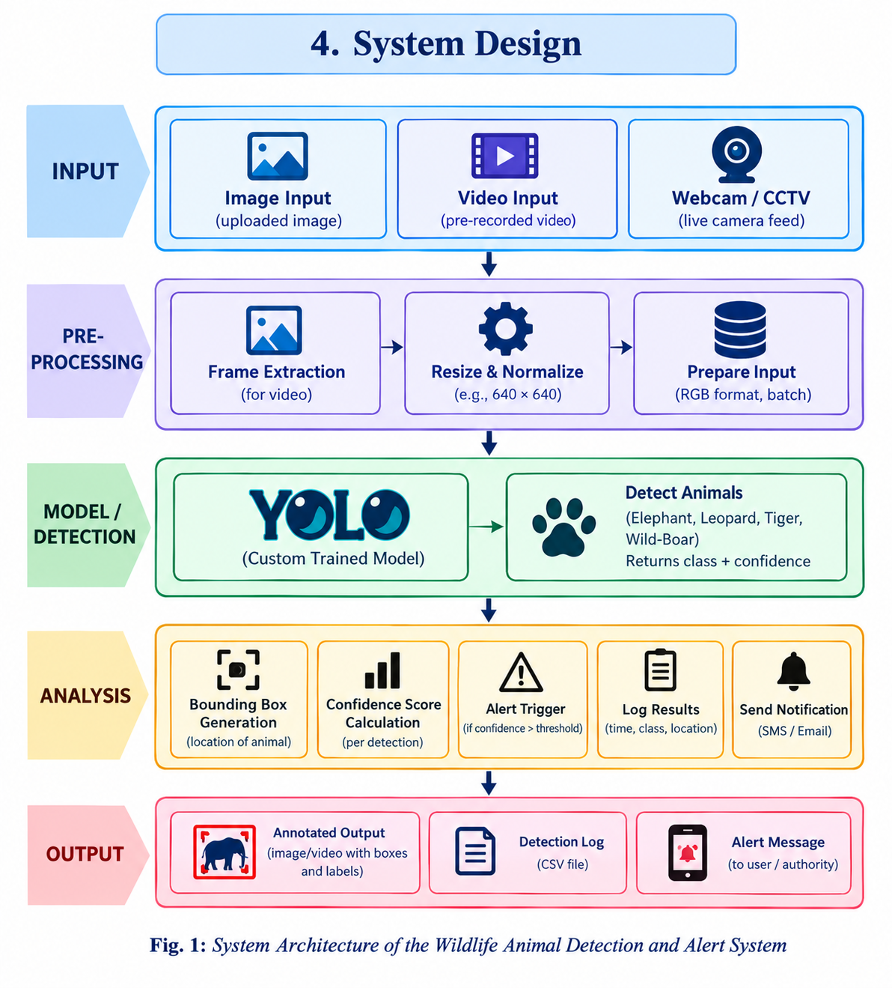

7. Result

The developed Wildlife Animal Detection and Alert System successfully detects the target wildlife classes Elephant, Leopard, Tiger, and Wild-Boar using a custom-trained YOLO object detection model. The model identifies the detected animal and provides a bounding box around the detected object.
To reduce false-positive detections, additional negative images of cats and dogs were included in the training dataset without assigning them any wildlife class labels. This helped the model distinguish non-target animals from the four target wildlife classes.
The trained model was then integrated into a Streamlit-based deployment application. The application provides an interface through which the user can operate the detection system and provide an email address for receiving alerts. When a target animal is detected, the system generates a warning notification containing information about the detected animal and sends the alert to the specified email address.
Thus, the developed system demonstrates an end-to-end workflow from wildlife detection to automated alert notification, making it suitable as a prototype for wildlife monitoring and early-warning applications.

8. Conclusion

The Wildlife Animal Detection and Alert System using YOLO was successfully developed to automatically detect selected wildlife animals from visual input and generate alerts when a target animal is identified. The system focuses on four classes: Elephant, Leopard, Tiger, and Wild-Boar.
The inclusion of negative cat and dog images helped improve the system's ability to distinguish target wildlife from non-target animals and reduce unwanted detections. The trained YOLO model was successfully integrated with a Streamlit application, providing a simple interface for using the detection system.
The email alert functionality further extends the system from simple object detection to an automated warning mechanism, allowing users to receive notifications when wildlife is detected. Overall, the project demonstrates how computer vision and deep learning can be combined with a web-based interface and automated communication to develop a practical prototype for wildlife monitoring and alert systems.

References:

[1] Ultralytics, “YOLO Documentation,” Ultralytics.

[2] J. Redmon et al., “You Only Look Once: Unified, Real-Time Object Detection,” IEEE/CVF Conference on Computer Vision and Pattern Recognition (CVPR), 2016.

[3] Y. Zhang et al., “ByteTrack: Multi-Object Tracking by Associating Every Detection Box,” ECCV, 2022.
[4] OpenCV, “OpenCV Documentation.”

[5] Roboflow, “Computer Vision Dataset and Annotation Documentation.”

[6] Flask, “Flask Web Development Documentation.”

[7] Streamlit, “Streamlit Documentation.” Streamlit Documentation

[8] Twilio, “Messaging API Documentation.”

